UPDATE IN AN ARRAY:
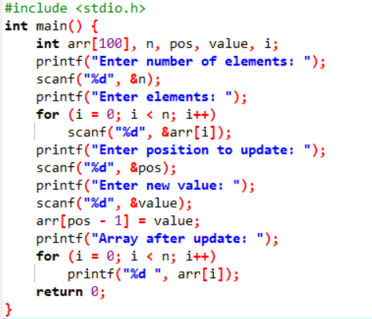\
OUTPUT:
